
PYTHON PROGRAMMING LAB FILE

Name: Krishna Som
Sap ID: 590025475
Batch: 34
Teacher: Sugandha Sharma

Experiment-4
Objective 1: Write a program to count and display the number of capital letters in a given string.
Code:
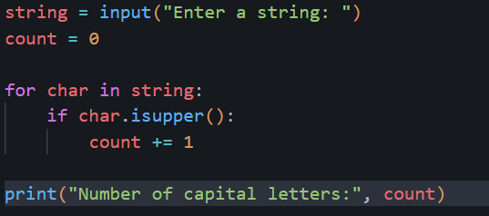
Output:
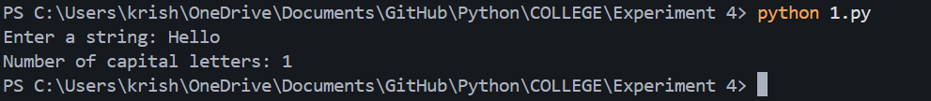
Objective 2: Count total number of vowels in a given string.
Code:
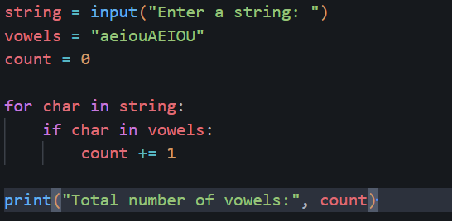
Output:
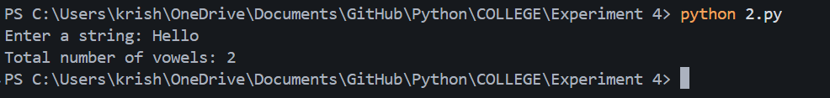
Objective 3: Input a sentence and print words in separate lines.
Code:
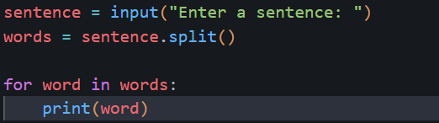
Output:
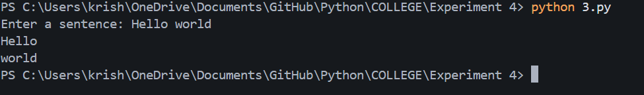
Objective 4: WAP to enter a string and a substring. You have to print the number of times that the substring occurs in the given string. String traversal will take place from left to right, not from right to left.
Code:
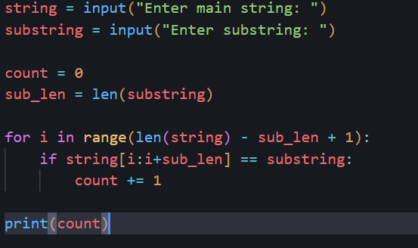
Output:
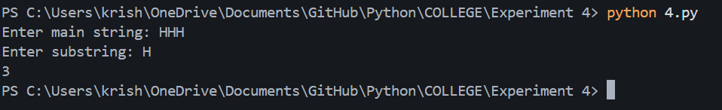

Objective 5: Given a string containing both upper- and lower-case alphabets. Write a Python program to count the number of occurrences of each alphabet (case insensitive) and display the same.
Code:
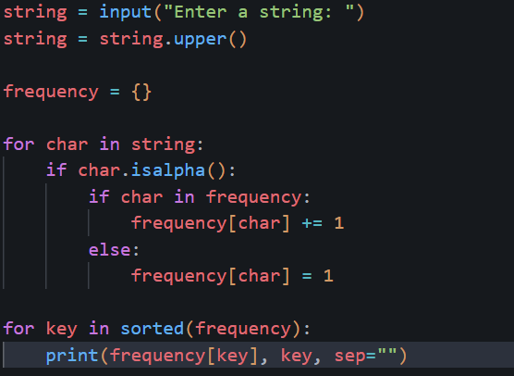
Output:
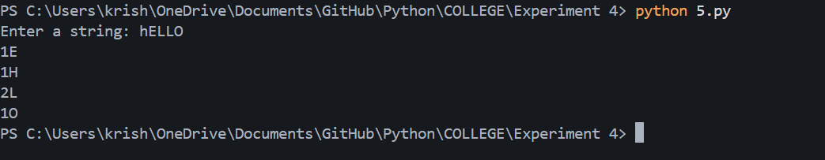
Objective 6: Program to count number of unique words in a given sentence using sets.
Code:
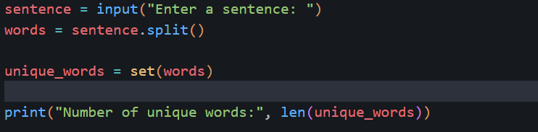
Output:
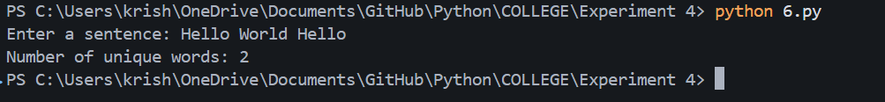

Objective 7: Create 2 sets s1 and s2 of n fruits each by taking input from user and find:
- Fruits which are in both sets s1 and s2
- Fruits only in s1 but not in s2
- Count of all fruits from s1 and s2
Code:
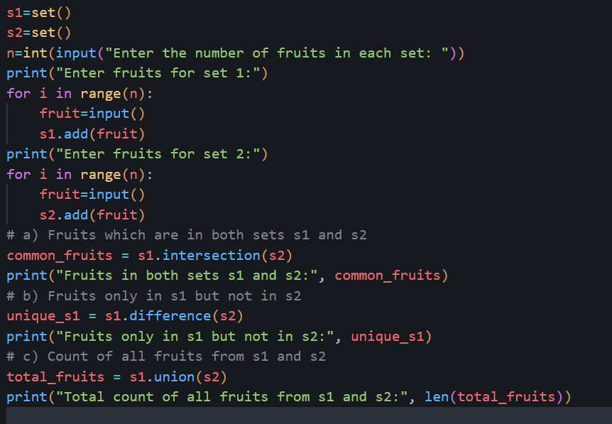
Output:
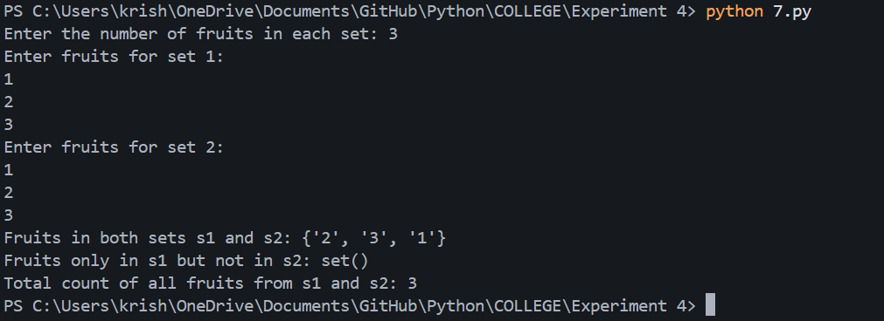

Objective 8: Take two sets and apply various set operations on them :
S1 = {Red, yellow, orange, blue }
S2 = {violet, blue, purple}

Code:
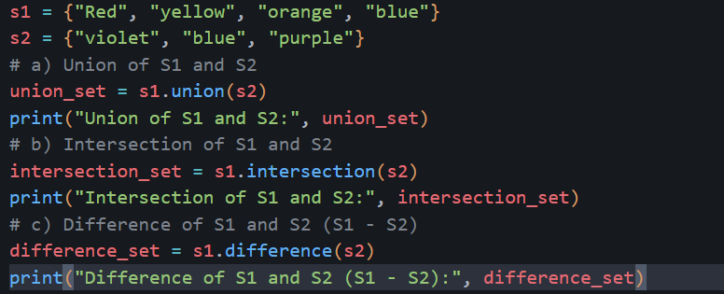
Output:
